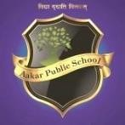
AAKAR PUBLIC SCHOOL
Piproli, Shivpuri Link Road, Gwalior
Winter Vacation (2023-24)
01/01/2024
Dear Gaurdian/Parents
The school will be remain closed on account of the piercing fog and frigid. Winter Vacation is declared in the school from Jan.02, 2024 to Jan. 06, 2024. It will reopen on Jan.08, 2024 (Monday) on its usual time for its academic functions.

Thank You.

Stay Happy & Healthy!
##Happy New Year! #

Anil Kumar Pandey
Principal

